**About the Sample Recruiting App**

First, let's learn a little more about our fictional company, Universal Containers.

Universal Containers is a rapidly growing international supplier of container products. The

company produces every kind of container from simple overnight letter mailers to custom

equipment packaging to large cargo shipping containers. In addition, Universal Containers

develops and maintains its own proprietary software to facilitate the design of its various types

of containers. As such, Universal Containers has a very diverse group of employees, including

facilities and operations professionals, software and design engineers, financial accountants,

and legal and human resources personnel.

Historically, the Human Resources department has used Microsoft Word documents and

Microsoft Excel spreadsheets to manage the recruiting and hiring process for new employees.

However, over the last two quarters it's become evident that unless this process is replaced by

one that is more collaborative, reliable, and scalable, the department won't be able to meet its

hiring goals for this fiscal year. Universal Containers needs a centralized application that can

bring all of its recruiting and hiring processes together, and the company has hired us to solve

this problem. Our approach will be to leverage their Salesforce account and build a recruiting

application on the Force.com platform. We're going to introduce Universal Containers to the

world of cloud computing!

**Considerations for the Recruiting App**

After meeting with Megan Smith, Universal Containers' vice president of Human Resources,

we've drawn up a few requirements for the new Recruiting app. The app needs to:

• Track positions in all stages of the process, from those that are open to those that have

been filled or canceled.

• Track all of the candidates who apply for a particular position, including the status of their

application (whether they've had a phone screen, are scheduled for interviews, have been

rejected or hired, or have passed on an offer that was presented).

• Track the posting of jobs on external employment websites, such as Monster.com.

• Allow employees to post reviews for candidates whom they've interviewed.

• Provide security for the recruiting data so that it's not mistakenly viewed, edited, or deleted

by employees who shouldn't have access.

• Automatically inform the relevant recruiter about the next steps that should be taken when

a decision has been made about an applicant.

• Automatically inform all employees of new positions that have been posted.

• Make sure that a new job opening has executive approval before it becomes active

• Include reports that give users an overview of recruiting status.

• Allow recruiters to map the locations of all candidates who are applying for a position, to

better understand relocation expenses.

• Make it easy to perform several similar tasks at once, like rejecting multiple job applications.

• Automatically post open positions on Universal Containers' public website.

An app that meets these requirements is going to greatly increase the efficiency of Universal

Containers' recruiting and hiring processes.

**Building the App: Our Design**

Let's take a look at the different parts of the Force.com platform that we'll use to implement

Universal Containers' Recruiting app. We'll learn about all of these things in a lot more detail

in later chapters, but for now, this quick preview will give you an idea about what's in store.

**Custom Objects**

Custom objects are the native components that model the data we need to store in our

Recruiting app. Similar to a database table, a custom object is composed of several fields that

store information such as a job applicant's name, or the maximum salary for a particular position.

However, unlike traditional database tables, we don't need to write any SQL in order to create

custom objects. We can simply point and click in the platform to create as many objects as we

need.

For our Recruiting app, we'll be creating six custom objects to track recruiting-related data:

• Position

• Candidate

• Job Application

• Review

• Job Posting

• Employment Website

Most of these objects will be displayed as tabs in our application. When a user clicks one of

the tabs, he or she will have access to individual instances of that particular object, as shown

in the following screenshot.



One of the powerful features of a custom object is the fact that it can have relationships with

other objects in the system. For example, for every review written by an interviewer and entered

into the system, we'll want to associate it with the job application of the candidate who was

being interviewed. Again, we won't need to write any SQL to make this happen—thanks to

the platform, defining a relationship will be as simple as a few clicks of the mouse.

**Security and Sharing Rules**

Another important function that we'll need to build into our app is the ability to restrict access

to data that particular users shouldn't see, without preventing other users from performing

their jobs effectively. We're going to implement this requirement with a group of components

that we've grouped under a single term: *security and sharing rules*.

With security and sharing rules, we'll first specify which custom objects a particular user should

be allowed to create, view, or edit (for example, Candidate and Position), and then which

instances of those objects should be accessible (for example, the records for candidate John

Smith or the Senior Sales Manager position). Controlling our data either with the wide brush

of object-level security or with the more detailed brush of record-level security will give us a

lot of power and flexibility in controlling what users can and can't see.

**Workflow and Approval Processes**

Three of our requirements involve automating business processes, such as triggering an alert

email to a recruiter whenever a job application's status has changed, and submitting new job

openings for executive approval. Once again, the Force.com platform makes these requirements

easy for us to implement natively with the built-in *workflow* and *approval process* components.

Workflow and approval processes allow us to create business logic based on rules:

• Workflow rules can assign tasks to users, update fields, or send email alerts.

• Approval processes allow users to submit sensitive records like new contracts or purchase

orders to other users for approval.

For example, in our Recruiting app, we can create a workflow rule that triggers an event

whenever the status of a job application has changed to Reject or Extend an Offer, as illustrated

below.



When a hiring manager makes a decision to either extend an offer to or reject the candidate,

changing the status of the application triggers the appropriate task to be assigned to the recruiter

for that position. Based upon the hiring manager’s decision, the recruiter performs the

appropriate follow-up task.

Similarly, we can define an automatic approval process that sends all new positions to the

appropriate management for approval. If the position is approved, its status automatically

changes to Open - Approved and recruiters can start the hiring process. If the position is

rejected, its status automatically changes to Closed - Not Approved and the position won't be

filled.

**Custom Reports and Dashboards**

Finally, we need to give users a way to inspect the status of all positions and job applicants in

the Universal Containers recruiting program. Managers need to delve into the intricate details

of how each recruiter is performing, while executives just want a high-level overview of how

departments are doing with staffing goals.

We can meet these requirements using reports and dashboards. Using report builder, we can

create detailed reports with filters, conditional highlighting, subtotals, and charts. With

dashboard builder, we can quickly create a dashboard of up to 20 different components on a

single page.

**Positions Related to Hiring Managers**



# Create a custom app call ‘Recruiting’

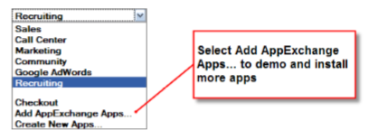

Introducing Objects Now that our app is functional (but rather boring), let's make it a little more interesting by introducing our first object

# Create the Position Custom Object

The first custom object that we'll create for our Recruiting app reflects a typical recruiting task: describing a position. Recruiters at Universal Containers need to keep track of all the positions they're hiring for, such as a Senior Developer, Sales Engineer, or Benefits Specialist.They'll need easy access to all positions in the system through a tab, and they'll need to include certain information for each position, such as its minimum and maximum salary range, the position's location, and its hiring manager.



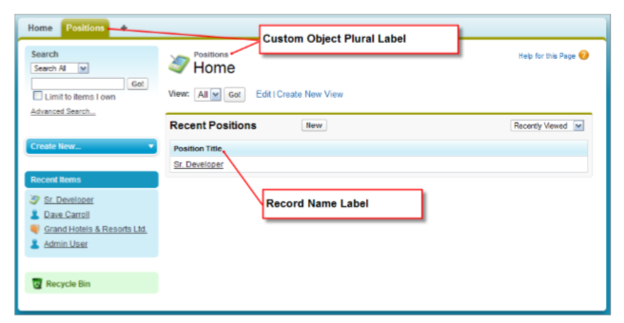

# Create Custom Fields



**Picklist**

**Location**:

San Francisco, CA • Austin,TX • Boulder, CO • London, England • New York, NY • Mumbai, India • Sydney, Australia • Tokyo, Japan

**Status:**

New Position, Pending Approval, Open – Approved, Closed – Filled, Closed - Not Approved

**Type:**

Full Time, Part Time, Internship, Contractor

**Functional Area:**

Finance, Human Resources, Information Technology, Retail Operations, Warehousing, Miscellaneous

**Job Level:**

FN-100, FN-200, FN-300, FN-400, HR-100, HR-200, HR-300, HR-400, IT-100, IT-200, IT-300, IT-400, RO-100, RO-200, RO-300, RO-400, WH-100, WH-200, WH-300, WH-400, MC-100, MC-200, MC-300, MC-400

**Dependant picklict**

Controlling Field: Functional Area

Dependent Field: Job Level.



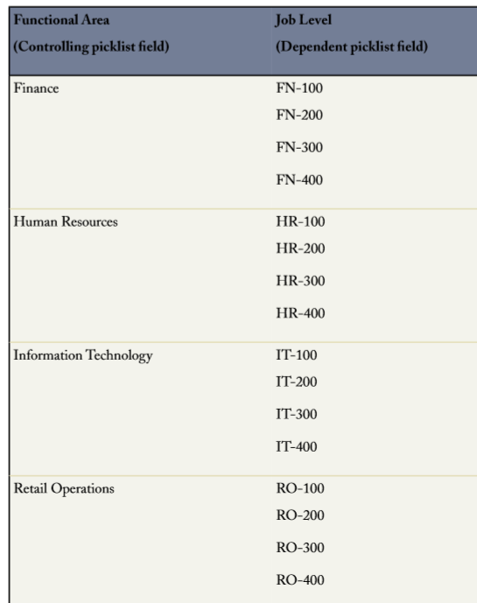

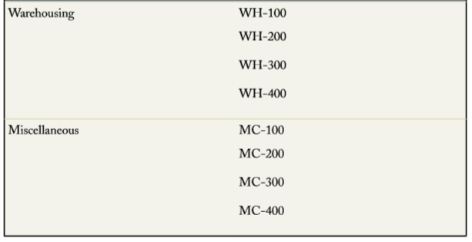

**Create Custom Formula Fields**

On our Position object, we've already created fields for minimum pay and maximum pay. If Universal Containers gives out yearly bonuses based on salary, we could create a custom formula field that automatically calculated the average bonus that someone hired to that position might receive.

To create a calculation, we'd enter a formula in a new column that averages the values of Min Pay and Max Pay in a single row and then multiplies it by a standard bonus percentage.We could then determine the average bonus for every position record row in our spreadsheet.

**Calculating How Long a Position Has Been Open**

Let's now think about another custom formula field that we could create for our Position object—a custom formula field that calculates how many days a position has been open

Let's think about the data that we need to make this calculation: we need to know the current date and the date that the position was created. If we could somehow subtract these two, we'd have the number of days that the position has been open. Fortunately, it's easy to get both of these values: • For the current date, we can simply use the platform's built-in TODAY() function.TODAY() returns today's date. • For the date that the position was opened, we can use the Open Date field

So far so good, but one problem still remains—what if the position has already closed? Our formula only works if we assume the position is still open. Once it closes, however, the value of our current formula will keep incrementing every day as TODAY() gets farther and farther away from the original Open Date. If we can, we want to use the Close Date field in the formula instead of TODAY() after a position closes.

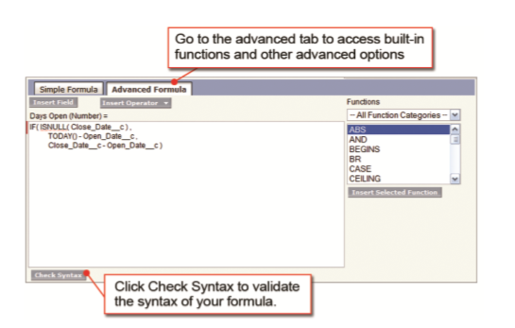

**Create ‘Hire By’ as formula field**

At Universal Containers, recruiters are generally expected to fill a position within 90 days of it being opened.While we can't choose a single date that will always be 90 days after a position is opened, we can define a custom formula that takes the date the position is created and adds 90 days.The platform allows us to specify this formula as the Hire By field's default value

## Test the application: Look at What We've Done

Let's revisit the Positions tab to take a look at what we've just done.

1. Click the Positions tab.

2. Click New. Our Days Open formula field doesn't show up on our Position edit page—that's because it's a formula field and doesn't require any user input to display. However, we can see that our Open Date and Hire By fields already have default values:Open Date should be today's date, and Hire By is 90 days later.We can change these values if we want, or we can just leave them as they are. In order to see our Days Open field, we'll have to define our first position record. Let's do that now.

3. Enter any values you want to define for a new position. At the very least, you must enter a value for the required Position Title field. 4. Click Save.

# Introducing Validation Rules

**Introducing Validation Rules**

Now that we've defined all the fields that we want on our Position object, let's see if we can

articulate a couple of rules about the data that should be entered into those fields. Even though

the recruiters and hiring managers at Universal Containers are bright people, everyone

sometimes makes mistakes when filling out a form, and a good app should catch the obvious

errors.

For example, does it ever make sense for the value of the Min Pay field to be more than the

value of the Max Pay field? Or should Close Date ever be unspecified if the Status field

is set to Closed - Filled or Closed - Not Approved? Clearly not. We can catch these sorts of

errors in our app with yet another built-in feature of the platform: *validation rules*.

Validation rules verify that the data a user enters in your app meets the standards that you

specify. If it doesn't, the validation rule prevents the record from being saved, and the user sees

an error message that you define either next to the problematic field or at the top of the edit

page. Let's build a couple of validation rules now for our Recruiting app.

1. **Defining a Validation Rule for Min and Max Pay**

Min Pay cannot exceed Max Pay



1. **Defining a Validation Rule for Close Date**

Close Date must be specified when Status is set to 'Closed.'

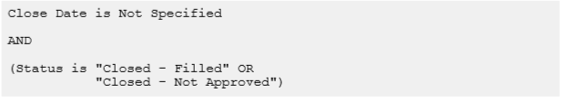

## Test the application: Look at What We've Done

Let's revisit the Positions tab to test the validation rules that we've just made.

1. Click the Positions tab.
2. 2. Click New. First let's try defining a new position with a value for Min Pay that's larger than Max Pay.
3. Specify any value for the required Position Title field.
4. In the Min Pay field, enter 80,000.
5. In the Max Pay field, enter 40,000.
6. Click Save.

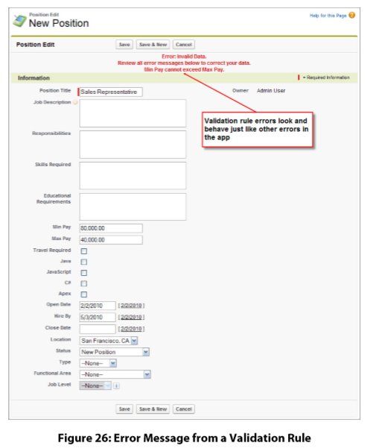

# Introducing Page Layouts

After defining all those fields and validation rules, we now have a fully functional Position

custom object. However, it doesn't look all that nice—all of the long text areas appear at the

top, and it's hard to scan. Let's move some things around to make this page easier for our users.

We can do that by customizing the Position object's page layout.

A *page layout* controls the position and organization of the fields and related lists that are visible

to users when viewing a record. Page layouts also help us control the visibility and editability

of the fields on a record. We can set fields as read-only or hidden, and we can also control

which fields require users to enter a value and which don't.

Page layouts are powerful tools for creating a good experience for our users, but it's crucial that

we remember one important rule: *page layouts should never be used to restrict access to sensitive*

*data that a user shouldn't view or edit*. Although we can hide a field from a page layout, users

can still access that field through other parts of the app, such as in reports or via the API.

Now let's see if we can organize the fields on our Position object in a way that's more user Friendly

## Edit position layout



The page layout editor consists of a palette at the top of the screen and the page layout below

it. The palette contains the user interface elements that are available for you to add to the page

layout, including fields, buttons, links, and related lists. To add one of these user interface

elements to the page layout, simply select the category to which the element belongs on the

left column of the palette and drag the element from the palette to the page layout. To remove

a user interface element from the page layout, drag the element from the page layout to the

right side of the palette, or click the X ( ) icon that appears when you hover over the field. A

toolbar above the palette provides various functions, such as saving and previewing your changes.

Now that we know what we're looking at, let's rearrange the fields in the way a user might

want to see them.

**Adding Spaces Between Fields**



## Grouping Fields into a New Section:

Add fields to the compensation section





**Editing Field Properties**

We just used the page layout editor to organize our Position page layout in a logical, easy-to-read

fashion, but the page layout editor lets us do more than design the presentation of data—we

can also use it to help determine which fields are required, and which fields are read-only:

• If a field is required, a user won't be able to create a position record without specifying a

value.

• If a field is read-only, a user who views a position record edit page won't be able to change

its value.

At this point, we don't have any fields that need to be read-only, but we do want to make sure

that the salary range is always defined for each position, so let's make the Min Pay and Max

Pay fields required. Once we do that, we'll be all done with our Position object!

To make the Min Pay and Max Pay fields required, we need to edit the properties of each

field:

## Test the application: Look at What We've Done



# Expanding the Simple App Using Relationships

**Introducing Relationships**

So what is a relationship, and why are they important for our app? Just as a personal relationship

is a two-way association between two people, in terms of relational data, a relationship is a

two-way association between two objects. Without relationships, we could build out as many

custom objects as we could think of, but they'd have no way of linking to one another.

For example, after building a Position object and a Job Application object, we could have lots

of information about a particular position and lots of information about a particular candidate

who's submitted an application for it, but there would be no way of seeing information about

the job application when looking at the position record, and no way of seeing information

about the position when looking at the job application record. That's just not right!

With relationships, we can make that connection and display data about other related object

records on a particular record's detail page. For example, once we define a relationship between

the Position and Job Application objects we just talked about, our position record can have a

related list of all the job applications for candidates who have applied for the position, while a

job application record can have a link to the positions for which that candidate is applying.

Suddenly the “people” at our Recruiting app “party” know some of the other guests, and the

app just got a lot more interesting.



**Introducing Relationship Custom Fields**

we can define a relationship between two objects through the use of common fields. On the platform, we can define

relationships between objects by creating a *relationship* custom field that associates one object

with another. A relationship field is a custom field on an object record that contains a link to

another record. When we place a relationship custom field on an object, we're effectively

creating a many-to-one relationship between the object on which the relationship field is placed

and the other object.

There are different types of relationship fields, each with different implications. The simplest

and most flexible type is a *lookup relationship* field, which creates a simple relationship between

two objects. For example, if we place a lookup relationship field on a Job Application object

that references position records, many job application records can be related to a single position

record. This will be reflected both with a new Position field on the job application record

and with a new Job Applications related list on the position record. You can also put multiple

lookup relationship fields on a single object, which means that our Job Application object can

also point to a Candidate object.

A second type of relationship field, *master-detail relationship*, is a bit more complex, but more

powerful. Master-detail relationships create a special parent-child relationship between objects:

the object on which you create the master-detail relationship field is the child or “detail,” and

the object referenced in the field is the parent or “master.” In a master-detail relationship, the

ownership and sharing of detail records are determined by the master record, and when you

delete the master record, all of its detail records are automatically deleted along with it.

Master-detail relationship fields are always required on detail records, and once you set a

master-detail relationship field's value, you can't change it.

When do you use a master-detail relationship? If you have an object that derives its significance

from another object. For example, say you have a Review custom object that contains an

interviewer's feedback on a job application. If you delete a job application record, you will

probably want all of its review records deleted as well, being that reviews of something that no

longer exists aren't very useful. In this case, you want to create a master-detail relationship on

the Review custom object with the Job Application object as the master object.

That's the sort of thing that we're going to do in this chapter. First, let's start with the really quick and easy example of putting a Hiring Manager field on our Position object—we'll

create a many-to-one relationship between the Position object and the standard User object

that comes with every organization, reflecting the fact that a hiring manager can be responsible

for several positions at a time. Then we'll build out a few more objects and implement a more

complex relationship involving positions, job applications, candidates, and reviews.

1. **Relating Hiring Managers to Positions** :

Create lookup relationship field on a Job Application object that references position records, many job application records can be related to a single position record.This will be reflected both with a new Position field on the job application record and with a new Job Applications related list on the position record.You can also put multiple lookup relationship fields on a single object, which means that our Job Application object can also point to a Candidate object.

1. Click Your Name ➤ Setup ➤ Create ➤ Objects.

2. Click Position.

3. In the Custom Fields & Relationships related list, click New.

4. Select Lookup Relationship, and click Next.

5. In the Related To drop-down list, choose User, and click Next. As we've mentioned, User is a standard object that comes with all organizations on the platform. It contains information about everyone who uses the app in your organization.

6. In the Field Label text box, enter Hiring Manager. Once you move your cursor, the Field Name text box should be automatically populated with Hiring_Manager.

7. Click Next.

8. Accept the defaults in the remaining two steps of the wizard.

9. Click Save.

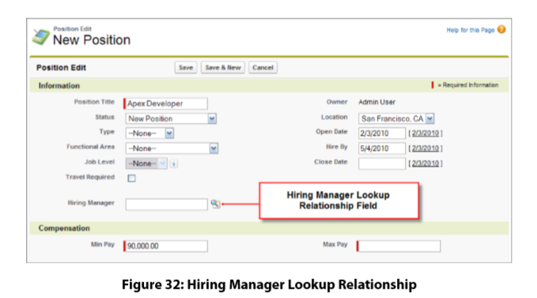

1. Adding Candidates to Application
2. If you delete a job application record, you will probably want all of its review records deleted as well, being that reviews of something that no longer exists aren't very useful. In this case, you want to create a master-detail relationship on the Review custom object with the Job Application object as the master object.

# Creating the Candidate Object

Defining the Candidate Object

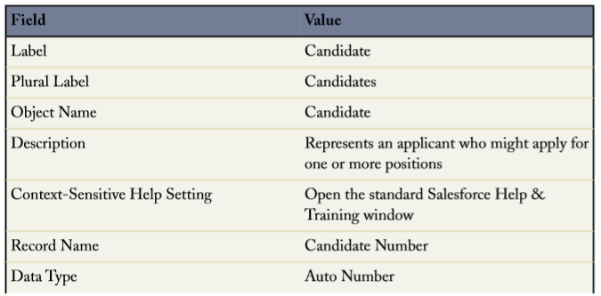

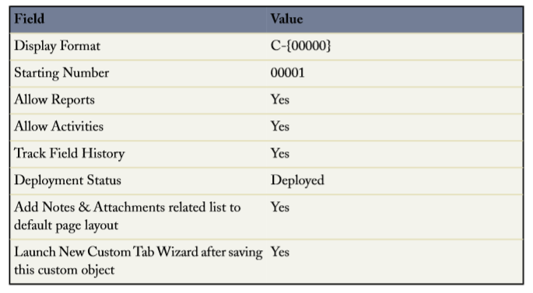

# Adding Fields to the Candidate Object

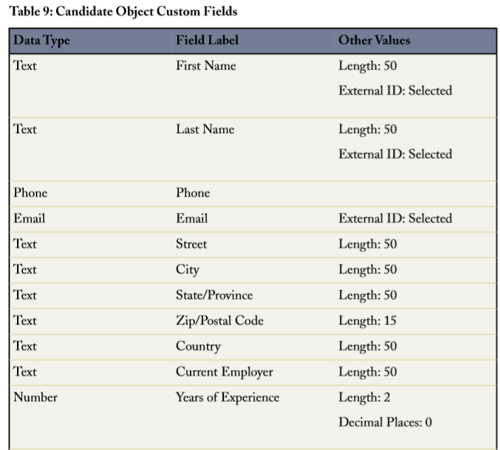

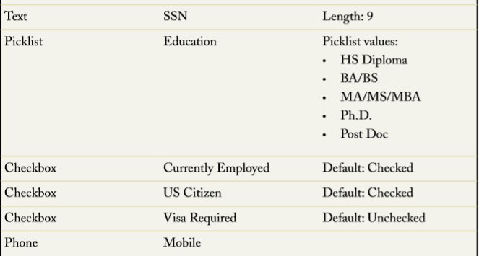



# Modifying the Candidate Page Layout Properties

Click Your Name ➤ Setup ➤ Create ➤ Objects.

2. Click Candidate.

3. In the Page Layouts related list, click Edit next to the Candidate Layout.

4. Create three new double-column sections below the Information section: Address, Employment, and Additional Details. Drag the appropriate fields into them, as shown in the Candidate Object Page Layout image, and don't forget to click Quick Save so you can save your work as you go.

5. Set the First Name,Last Name, and Email fields to required as follows: a. Use CTRL+click to select all three required fields. b. Double-click your selection. c. Select the Required checkbox in the Select All row, and click OK.

6. Click Save.

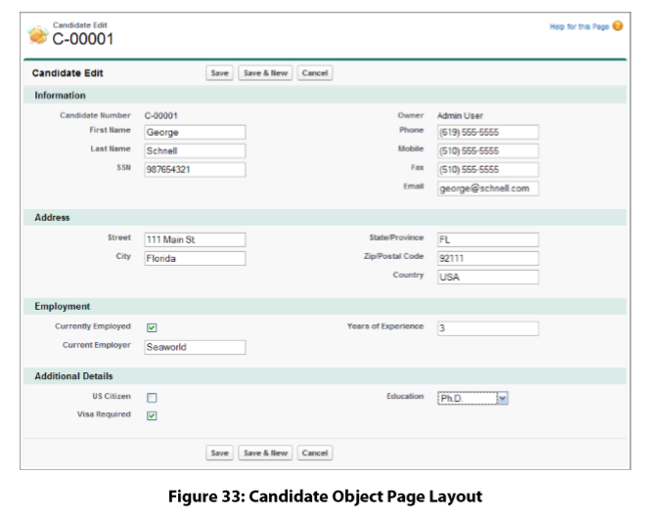

## Test the application: Look at What We've Done

1. Click the Candidates tab.

2. Click New.

3. Create a new record for a candidate named Ethan Tran.

4. Enter a value for each of the required fields.Salesforce will not verify the email address you enter in the Email field right now, so feel free to enter a fictitious one.

5. Click Save

Our app can track candidates and open positions, but there's a crucial element that's missing: how do we know which candidates are interested in which positions? We can create lookup relationship fields on the Candidate object that let recruiters specify the positions in which the candidate is interested, but what if we want to track additional information, such as whether the candidate is currently scheduled to interview for one of those positions? And wouldn't it be helpful if the recruiter has a way of storing the cover letters that candidates tailor for each specific job to which they are applying?

We can satisfy these requirements with a Job Application custom object that stores data about an individual candidate's application to a single position. Each time a candidate wants to apply for a position, the recruiter can create a job application record that contains the candidate's name and the position to which he or she is applying, as well as any cover letter that the candidate may have submitted specifically for that position. Recruiters will also be able to indicate the status of the candidate's application, such as whether he or she is scheduled for an interview or if the application has been rejected. After we create the Job Application object and its fields, we'll make a few small modifications to the Position, Candidate, and Job Application objects so that each position record displays the names of the candidates who have applied to it, and each candidate record displays the name of the positions to which the candidate has applied.

# Creating the Job Application Object

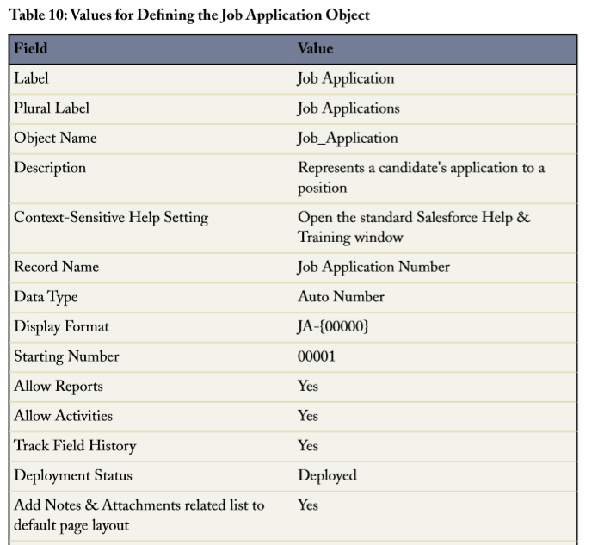

# Adding Fields to the Job Application Object

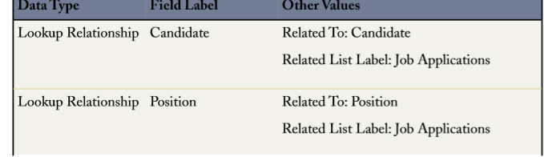

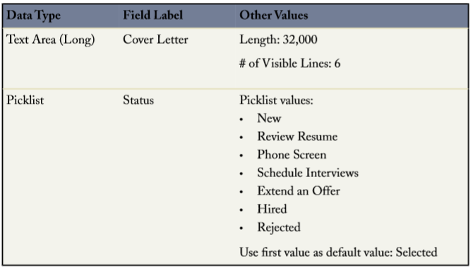

# Create child relationship

1. Click Your Name ➤ Setup ➤ Create ➤ Objects, and click Job Application.

2. In the Custom Fields & Relationships related list, click Position, then click Edit.

3. In the Child Relationship Name field, enter Job Applications and click Save.The Force.com platform saves the child relationship name as Job_Applications.

## Test the application: Look at What We've Done

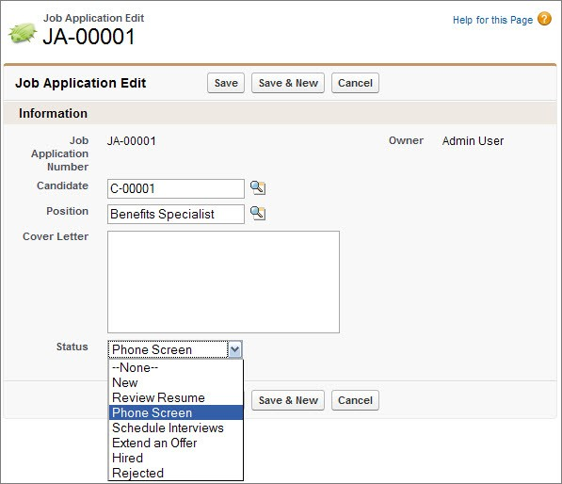

**Custom Fields on the Job Application Edit Page**

# Job Application Links to Position and Candidate Data

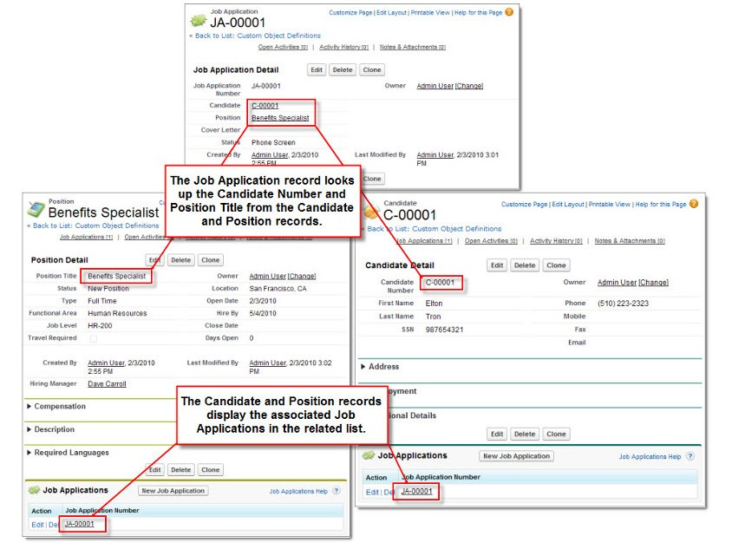

**Managing Review Assessments**

Interviewers, recruiters, and hiring managers need to be able to create reviews so that they can record their comments about each candidate's job application, and rate the candidate's suitability for the position. They also need to see the reviews posted by other people. To allow our users to perform these tasks, we'll need to create a custom Review object and relate it to the Job Application object.

The Review object has a many-to-one relationship with the Job Application object because one job application can have one or more reviews associated with it. A related list on the job application record will show the associated reviews, representing the “many” side of the relationship.

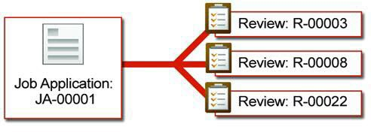

However, instead of creating this relationship with a lookup relationship field, this time we'll use a master-detail relationship field. A master-detail relationship field makes sense in this case because reviews lose their meaning when taken out of the context of a job application, so we'll want to automatically delete reviews when we delete the job application to which they're related.

**Creating the Review Object**

**Values for Defining the Review Object**

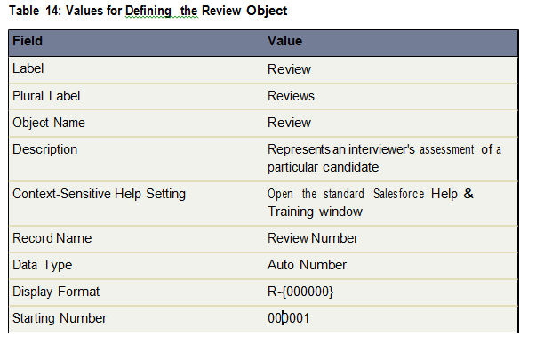

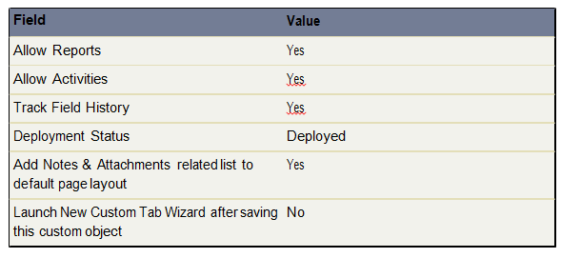

**Adding Fields to the Review Object**

Let's start by adding the master-detail relationship field, which will relate our Review object with the Job Application object

**1.** From Setup, click **Create** > **Objects**.

**2.** Click **Review**.

**3.** In the Custom Fields & Relationships related list, click **New**.

**4.** Select Master-Detail Relationship, and click **Next**.

**5.** In the Related To drop-down list, choose Job Application, and click **Next**.

**6.** Click in the Field Label text box to automatically populate it with the field name

Job_Application.

**7.** Leave the Read/Write radio button selected.

This sharing setting prevents people creating, editing, or deleting a review unless they can also create, edit, or delete the from associated job application. We'll learn about sharing and security in the next chapter.

**8.** Click **Next**.

**9.** Accept the defaults in the remaining three steps of the wizard.

**10.** Click **Save**.

Your master-detail relationship is complete!

Now that your master-detail relationship is in place, let's think about the other types of fields that would be useful to people looking at a review record.

Most likely, users will want to see the name of the candidate and the position for which they are being reviewed. We could create a lookup relationship to the Position and Candidate objects, and then require reviewers to enter those fields when creating a review record, but what if they select the wrong value? Besides, wouldn't it be better if these fields were somehow automatically populated?

To solve this, we'll tap into the synergy of formulas and relationships to create *cross-object formulas*. Cross-object formulas are formulas that span two or more objects by referencing merge fields from related records. This means that formulas on our Review object can access fields on the Job Application object, and formulas on the Job Application object can access fields on both the Position and Candidate objects. We're going to take it even one step further by creating formula fields on our Review object that *span* the Job Application object to reference

fields on the Candidate and Position objects. You'll quickly discover that using related data is much easier than it sounds!

Let's begin by building a formula field on the Review object that references the title of the position on the review's parent job application record.

**1.** From Setup, click **Create** > **Objects**.

**2.** Click **Review**.

**3.** In the Custom Fields & Relationships related list, click **New**.

**4.** Select the Formula data type, and click **Next**.

**5.** In the Field Label field, enter Position. Once you move your cursor, the

Field Name text box automatically populates with Position.

**6.** Select the Text formula return type and click **Next**.

**7.** Click the **Insert Field** button.

The Insert Field overlay appears, as shown below.

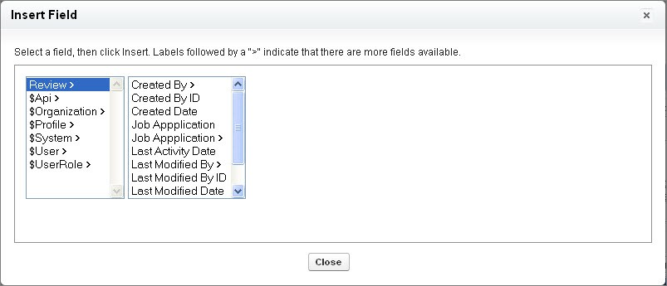

**Figure 42: Insert Field Overlay**

**8.** Select Review in the first column.

When you choose Review, the second column displays all of the Review object's fields as well as its related objects, which are denoted by a greater-than sign (>). Notice that the Created By and Last Modified By fields also have greater-than signs. This is because these are lookup fields to the User object.

**9.** Select Job Application > in the second column. The third column displays the fields of the Job Application object.

**10.** Select Position > in the third column. The fourth column displays the fields of the Position object.

Be sure that you select Position > (with the greater than sign) and not Position. The one with the greater-than sign is the Position object, while the one without the greater than sign is the Position lookup field on the Job Application object. In most cases, formulas that access lookup fields return a cryptic record ID. Instead, we want our formula to return the position's title.

**11.** Choose Position Title in the fourth column.

**12.** Click **Insert**.

Your formula now looks like this:

Job_Application r.Position r.Name

The formula spans to the review's related job application (Job_Application r), then to the job application's related position (Position r), and finally references the position's title (Name). Notice that each part of the formula is separated by a period, and that the relationship names consist of the related object followed by r.

**13.** Click **Next**.

**14.** Accept all remaining field-level security and page layout defaults.

**15.** Click **Save**.

That wraps up our first cross-object formula field. Let's try another. This time, we'll add a cross-object formula field on our Review object that displays the first and last names of the candidate being reviewed. We'll also up the ante by using the HYPERLINK function so that users can access the candidate's record by clicking the field.

**1.** From Setup, click **Create** > **Objects**.

**2.** Click **Review**.

**3.** In the Custom Fields & Relationships related list, click **New**.

**4.** Select the Formula data type, and click **Next**.

**5.** In the Field Label field, enter Candidate. Once you move your cursor, the

Field Name text box automatically populates with Candidate.

**6.** Select the Text formula return type and click **Next**.

**7.** From the Functions list, double-click HYPERLINK.

The HYPERLINK function lets you create a hyperlink to any URL or record in Salesforce. The text of the hyperlink can differ from the URL itself, which is useful here because we want our hyperlink to display the first and last names of the candidate while the URL points to the candidate record itself.

**8.** Delete *url* from the HYPERLINK function you just inserted, but leave your cursor there.

**9.** Click the **Insert Field** button, and select Review >, Job Application >,

Candidate >, Record ID, and click **Insert**.

Salesforce generates a unique ID for every record. By inserting the record ID of the candidate in our HYPERLINK function, we're enabling our formula field to locate and link to the candidate's record.

**10.** Delete *friendly_name* from the HYPERLINK function, but leave your cursor there.

**11.** Click the **Insert Field** button, and select Review >, Job Application >,

Candidate >, First Name, then click **Insert**.

**12.** Enter a space, then click the **Insert Operator** button and choose Concatenate.

The Concatenate operator inserts an ampersand (&) in your formula, and joins the values on either side of the ampersand. Here we're going to use the Concatenate operator to join the first and last names of the candidate in a single field, even though they are stored in separate fields on the Candidate object. The Concatenate operator also lets us insert a space between the two names, as you'll see in the next step.

**13.** Enter another space, then type a blank space enclosed in quotes, like this:

" "

This appends a blank space after the first name of the candidate.

**14.** Enter a space, then click the **Insert Operator** button and choose Concatenate once more to add a second ampersand in your formula.

**15.** Click the **Insert Field** button, and select Review >, Job Application >,

Candidate >, Last Name, then click **Insert**.

**16.** Delete *[ target ]* from the HYPERLINK function. This is an optional parameter that isn't necessary for our formula field.

**17.** Click **Check Syntax** to check your formula for errors. Your finished formula should look like this:

HYPERLINK

( Job_Application r.Candidate r.Id ,

Job_Application r.Candidate r.First_Name c

&

" "

&

Job_Application r.Candidate r.Last_Name c )

**18.** Click **Next**.

**19.** Accept all remaining field-level security and page layout defaults.

**20.** Click **Save**.

Whew! That one required a little more thought, but using a bit of brainpower here has tremendously improved the usability of our app, which you'll see in a moment when we test our changes to the Review object. Before we start testing, though, let's quickly add two more easy fields to finish our Review object. We need a text area field for the reviewer's assessment, and a number field in which the reviewer can give the candidate a numeric score.

**: Add Custom Fields to the Review Object**

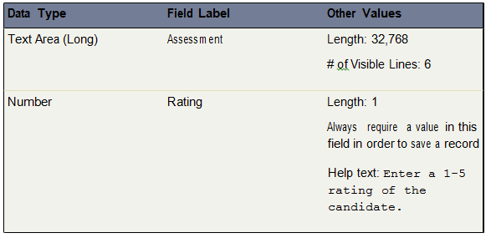

# Create Validation rule on Review Object:

Invalid rating. Rating must be from 1 to 5.

# Introducing Roll-Up Summary Fields as ‘Total Rating (SUM.)’ and ‘Number of Reviews (COUNT)’ on Job Application object

The rating system we created on the Review object lets users quickly see each reviewer's opinion of the candidate's suitability for the position. While each individual opinion is important, it would be even better to see these ratings compiled in a way that summarizes how the candidate did overall. For example, wouldn't it be great if we could have a Total Rating field on each Job Application record that shows the sum of all the job application's review ratings?

The good news is that we can! A simple roll-up summary field on the Job Application object can summarize data from a set of related detail records and automatically display the output on a master record. Use roll-up summary fields to display the sum, minimum, or maximum value of a field in a related list, or the record count of all records listed in a related list.

Both roll-up summary fields are in place now. Let's build a formula field called Average

Rating that divides the value of the first roll-up summary field by the value of the second.

**1.** From Setup, click **Create** > **Objects**.

**2.** Click **Job Application**.

**3.** In the Custom Fields & Relationships related list, click **New**.

**4.** Select the Formula data type, and click **Next**.

**5.** In the Field Label field, enter Average Rating. Once you move your cursor, the Field Name text box automatically populates with Average_Rating.

**6.** Select the Number formula return type and click **Next**.

**7.** Click the **Insert Field** button.

**8.** Select Job Application >, then Total Rating, and click **Insert**.

**9.** Click the **Insert Operator** button and choose Divide.

**10.** Click the **Insert Field** button again.

**11.** Choose Job Application >, then Number of Reviews, and click **Insert**. Your formula should look like this:

Total_Rating c / Number_of_Reviews c

**12.** Click **Next**.

**13.** Accept the defaults in the remaining steps of the wizard.

**14.** Click **Save**.

That wraps up all the fields and relationships we need to manage our reviews. Let's quickly organize the presentation of our fields and then test everything we've created.

**Creating a Many-to-Many Relationship**

Our Recruiting app now has quite a few many-to-one relationships, but what if we needed to create a many-to-many relationship? For example, what if we have an object that stored information about various employment websites, and we wanted to track which open positions we posted to those sites? This would require a many-to-many relationship because:

• One position could be posted on many employment websites.

• One employment website could list many positions.

Here's where we get a little creative. Instead of creating a relationship field on the Position object that directly links to the Employment Website object, we can link them using a *junction object*. A junction object is a custom object with two master-detail relationships, and is the key to making a many-to-many relationship.

For our app, we're going to create a junction object called Job Posting. A job posting fits into the space between positions and employment websites—one position can be posted many times, and one employment website can have many job postings, but a job posting always represents a posting about a single position on a single employment website. In essence, the Job Posting object has a many-to-one relationship with both the Position and the Employment Website objects, and through those many-to-one relationships, we'll have a many-to-many relationship between the Position and Employment Website objects.

**Tip:** In many apps, the sole purpose of a junction object is to simply relate two objects, so it often makes sense to give the junction object a name that indicates the association or relationship it creates. For example, if you wanted to use a junction object to create a many-to-many relationship between bugs and cases, you could name the junction object BugCaseAssociation.



Let's look at a typical scenario at Universal Containers. There are open positions for a Project Manager and a Sr. Developer. The Project Manager position is only posted on Monster.com, but the Sr. Developer position is more difficult to fill, so it's posted on both Monster.com and Dice. Every time a position is posted, a job posting record tracks the post. As you can see in the following diagram, one position can be posted many times, and both positions can be posted to the same employment website.

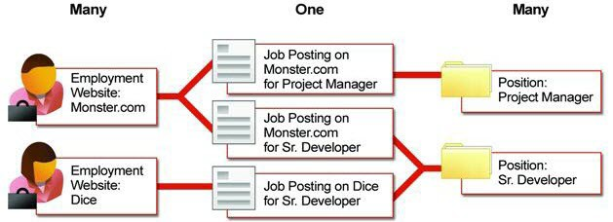

**Figure 43: Using a Job Posting Object to Create a Many-to-Many Relationship Between**

**Positions and Employment Websites**

In relational database terms, each job posting record is a row in the Job Posting table consisting of a foreign key to a position record and a foreign key to an employment website record. The following entity relationship diagram shows this relationship.

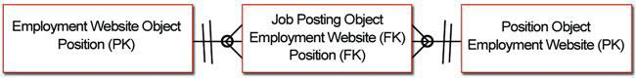

**Figure 44: Entity Relationship Diagram for the Position, Job Posting, and Employment**

**Website Objects**

Consequently, in order to define a many-to-many relationship between the Position and Employment Website objects, we'll need to create a Job Posting object with the following fields:

• A Position master-detail relationship

• An Employment Website master-detail relationship

Let's get started.

**Creating the Employment Website Object**

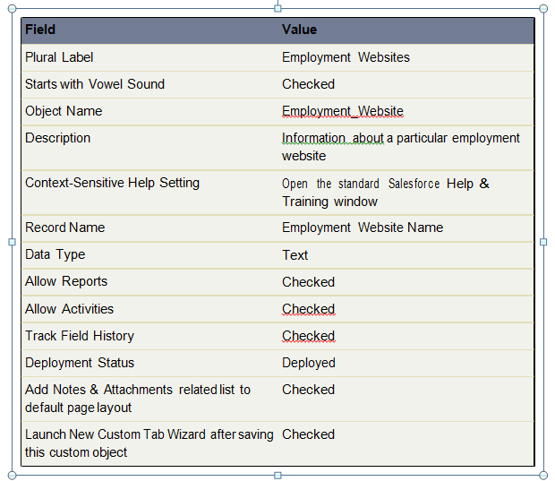

**Adding the URL Field to the Employment Website**

**Object**

Obviously, the Employment Website object needs to store the Web address of the employment website. We'll use the URL data type for this field. That way, when users click the field, the URL will open in a separate browser window. In addition to the URL, since most employment websites charge per posting, we'll want to keep track of how much it costs to post there, as well as our maximum budget for posting on the site.

From Setup, click **Create** > **Objects**, and then click **Employment Website** to view its detail page. In the Custom Fields & Relationships related list, use the **New** button to create three custom fields according to the following table. Where necessary, we've indicated some additional values you'll need to fill in when creating the fields. Otherwise you can simply accept all defaults.

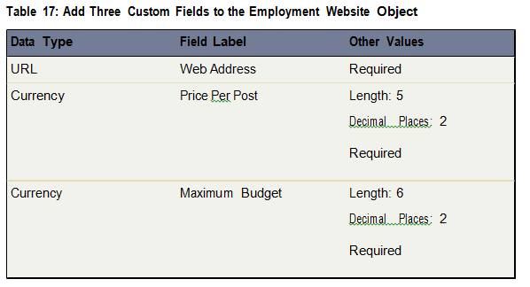

**Creating the Job Posting Object**

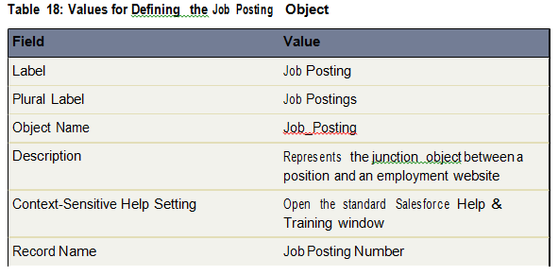

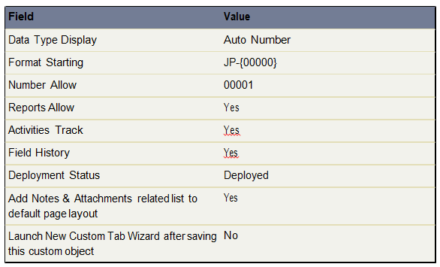

**Adding Fields to the Job Posting Object**

To turn the Job Posting object into the junction object that relates the Position and Employment Website objects, we'll need to add two master-detail relationship fields. The first master-detail relationship will be the *primary relationship*. The detail and edit pages of our junction object (Job Posting) will use the color and any associated icon of the primary master object (Position). In addition, the junction object records will inherit the value of the Owner field and sharing settings from their associated primary master record.

**1.** From Setup, click **Create** > **Objects**.

**2.** Click **Job Posting**.

**3.** In the Custom Fields & Relationships related list, click **New**.

**4.** Select Master-Detail Relationship, and click **Next**.

**5.** In the Related To drop-down list, choose Position, and click **Next**.

**6.** In the Field Label text box, enter Position. When you move your cursor, the

Field Name text box should be automatically populated with Position as well.

**7.** Accept the remaining defaults, and click **Next** until you reach the final step of the wizard.

Here, we are given the chance to add the Job Postings related list to the Position object page layout. Instead of displaying information about related job postings, we want this list to show all the employment websites where this position is posted. So let's add the Job Posting related list, but rename it Employment Websites.

**8.** In the Related List Label text box, enter Employment Websites.

**9.** Accept the other defaults and click **Save & New**.

We're halfway through the creation of our many-to-many relationship. The next step is to create a second master-detail relationship on the Job Posting object to link it with the Employment Website object.

The second master-detail relationship creates a *secondary relationship*. Unlike the primary relationship, the secondary relationship has no affect on the look and feel of the junction object. However, just as in the primary relationship, the sharing settings of the master record in the secondary relationship also affect who can access the junction record, and deleting a record of the secondary master object will automatically delete its associated junction object records. So in our app, if you delete an employment website record, all of its associated job posting records are deleted as well, even if the position is open.

**10.** Select Master-Detail Relationship, and click **Next**.

**11.** In the Related To drop-down list, choose Employment Website, and click **Next**.

**12.** In the Field Label text box, enter Employment Website. When you move your cursor, the Field Name text box should be automatically populated with Employment_Website as well.

**13.** Click **Next**. Because we are creating a master-detail relationship, these settings cannot be changed.

**14.** Click **Next**. These settings cannot be changed as well.

**15.** Click **Next** to view the final step of the wizard.

This time we are given the chance to add the Job Postings related list to Employment Website object page layout. We'll eventually configure this related list to show all the positions that are posted on this website, so let's add the Job Postings related list but rename it Positions.

**16.** In the Related List Label text box, enter Positions.

**17.** Accept the other defaults and click **Save**.

Now our many-to-many relationship is complete! Or is it?

While we have an Employment Websites related list on the Position object and a Positions related list on the Employment Websites object, both related lists still display job posting records. This won't do.

In order to achieve our goal of listing multiple positions on an employment website record and multiple employment websites on a position record, we need to customize the fields in these related lists.

**Customizing Related Lists in a Many-to-Many Relationship**

The capability to customize related lists in a many-to-many relationship is more robust than the capability to customize related lists in a lookup relationship. When you have a lookup relationship between two objects (like the one we created between the Job Application and Candidate objects), the related list on one object can only display fields from the object to which it is directly related; it cannot span to other objects the way formulas can. For example, the Job Applications related list on a candidate record can display any job application field, but it can't display any fields from the Position object, even though the Job Application object has lookup relationships with both the Candidate and Position objects.

Fortunately for us, many-to-many relationships allow for greater flexibility. When working with a many-to-many relationship, the junction object's related list on one master object can display the other master object's fields. We're going to take advantage of this by configuring the Positions related list on each employment website record to display fields from the Position object and vice versa, thus allowing these two objects to span to each other. It's all coming together now!

**Try It Out: Customizing the Positions and Employment Websites**

**Related Lists**

Let's start by modifying the Employment Websites related list on the Position object.

**1.** From Setup, click **Create** > **Objects**.

**2.** Click **Position**.

**3.** In the Page Layouts related list, click **Edit** next to the Position Layout.

**4.** Locate the Employment Websites related list and click its wrench () icon.

In the popup window that appears, you'll notice the Available Fields column lists fields from both the Job Posting object and the Employment Website object. If there wasn't a master-detail relationship between job postings and employment websites, the Available Fields column list would only list job posting fields.

**5.** Move the Employment Website: Employment Website Name and Employment Website: Web Address fields to the Selected Fields column, and use the up and down arrows to arrange the fields in the following order:

• Employment Website: Employment Website Name

• Employment Website: Web Address

• Job Posting: Job Number

**6.** Click **OK**.

**7.** Click **Save** on the page layout.

Now do the same for the Positions related list on the Employment Website object as follows:

**1.** From Setup, click **Create** > **Objects**.

**2.** Click **Employment Website**.

**3.** In the Page Layouts related list, click **Edit** next to the Employment Website Layout.

**4.** Locate the Positions related list and click its wrench icon ().

**5.** Move the following fields to the Selected Fields column, and use the up and down arrows to arrange them in the following order:

• Position: Position Title

• Job Posting: Job Posting Number

• Position: Functional Area

• Position: Location

• Position: Open Date

**6.** Click **OK**.

**7.** Click **Save** on the page layout.

**Look at What We've Done**

Our many-to-many relationship is complete! Let's see it in action.

**1.** Create a few sample position and employment website records.

**2.** Scroll down to the Employment Websites related list at the bottom of any position record, and click **New Job Posting**. The Job Posting edit page appears.

**3.** Use the lookup icon to select the employment website where you want to post the position, and click **Save**.

The Employment Websites related list on that position now shows the name and Web address of the website to which you just posted, as well as the job posting number. Click the name of the employment website in the related list and scroll down to view the Positions related list, which shows all the positions posted to that website.

Now you know how easy it is to make related information just a click away!

**Putting it All Together**

We just created several objects and a lot of relationships. The following simple diagram shows us what we've accomplished so far.

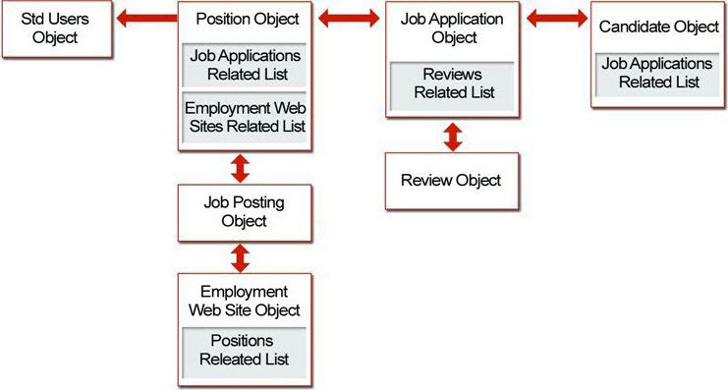

**Figure 45: Recruiting App Relationships**

All of these relationships, objects, and fields are shown below in an entity relationship diagram. An entity relationship diagram (ERD) is a conceptual representation of structured data, and is especially useful for planning and understanding an app.

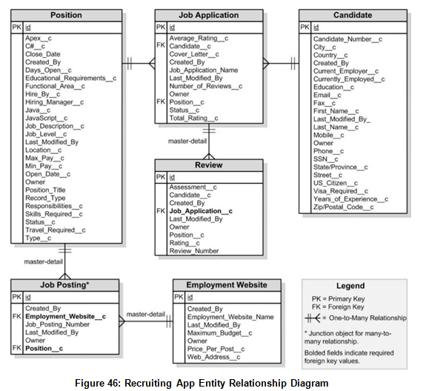

We've now built all of our Recruiting app objects and tabs, and we've defined lots of custom fields—everything from text fields and picklists to more complex formula fields and lookup relationship fields. We've created a robust user interface so that our recruiters and hiring managers can enter and retrieve data about positions and related candidates, job applications, and reviews, and we did all of this without writing a single line of code!

Remember when we assigned Anastasia O’Toole as the hiring manager for the Benefits Specialist position? Let's look at what Anastasia can do now: She can create and update her positions, and track which websites she's posted them on. She can look at details about any candidates who have applied for the Benefits Specialist job, and she can review their related job applications. She can also check the status of the job applications. She no longer has to go

to Human Resources to search through Microsoft Word documents and spreadsheets to manage her tasks in the hiring process. The Recruiting app is well on its way to becoming a

fully-functional and useful application!

However, before we leave this chapter behind, let's get ourselves prepared for the rest of this book by creating and importing some real data. It'll help us when we get to our next chapter on security and sharing if we have some records that we can work with.

**Using Custom Workflow and Approval**

**Processes**

**Workflow in Our Recruiting App**

Now that we've oriented ourselves to the different components involved with workflow, let's take a look at our Recruiting app and see how we can use workflow to help us build out the requirements that we talked about in About the Sample Recruiting App on page 19. Then we'll spend time implementing the rules that we come up with here.

We've already talked about one instance where workflow will give us a big advantage: automatically assigning a task to a recruiter when the status of a job application record changes to Reject or Extend an Offer. This will be a great start, but what else can we do?

If we look back at our last chapter on security and sharing, recall that we wanted to grant both recruiters and hiring managers permission to create new positions, but that ultimately we always wanted a recruiter to own those records because filling them is the recruiter's job responsibility. We hinted in the security and sharing chapter that we could accomplish this with workflow, and indeed we can! We'll simply need to use a workflow field update to change the record owner of a position record to a recruiter if it was originally created by a hiring manager. To prevent a single recruiter from getting overloaded with all these additional positions, we'll also

use another platform feature, *queues*, to divvy up the orphaned position records fairly. We'll place the record in a queue of other position records without owners, and then let individual recruiters claim the positions they want.

For a third way of using workflow, let's think about how position availability is advertised throughout Universal Containers. Like many organizations, Universal Containers prefers to fill positions with employee referrals, but employees often aren't aware of which positions are currently open. We can use a workflow alert to automatically send email to every employee whenever a new position opens up. This way employees learn about positions as they become available and can immediately think of friends and family members who might be interested.

Sound good? While there are probably many more ways to use workflow to build a killer

on-demand Recruiting app in the cloud, let's stick with these three for now since they'll give us a good example of each of the three types of workflow actions that are available. To summarize what we'll be building:

**1.** A workflow task that assigns a task to a recruiter when the status of a job application changes to Rejected or Extend an Offer

**2.** A workflow field update that reassigns ownership of a position that's created by a hiring manager to a queue of position records without owners, so that individual recruiters can claim ownership of the positions they want

**3.** A workflow alert that sends an email to every employee when a new position is created

Now let's get started!

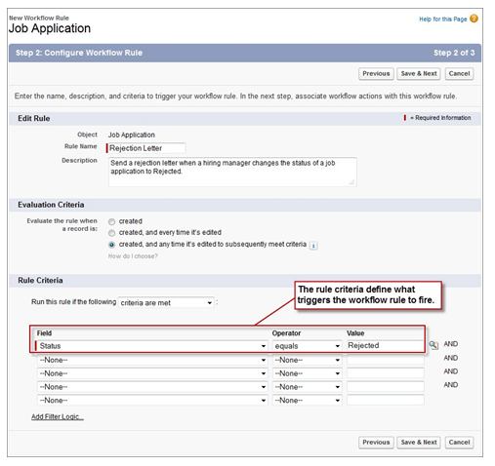



**Creating Workflow Rules That Assign Tasks**

For our first use of workflow, we want to create two rules: one that assigns a “Send Rejection Letter” task to the relevant recruiter whenever the Status field of a job application record is set to Rejected, and one that assigns an “Extend Offer” task to the relevant recruiter whenever the Status field of a job application record is set to “Extend an Offer.” Let's start with the “Send Rejection Letter” workflow rule.

**Try It Out: Creating the “Send Rejection Letter” Workflow Rule**

To make this rule entirely functional, we'll need to define both a workflow rule, which specifies the criteria for when the rule should be executed, and a workflow task that includes the “Send Rejection Letter” task template. Although we can define workflow components in any order. let's start with defining the workflow rule itself. It'll save us a couple of clicks a little later when we define the rule's associated workflow task.

You can either define actions that occur immediately after the condition is met, or you can define actions that occur before or after a certain amount of time has elapsed (for example, seven days before the value of the Hire By field, or three days after the workflow rule is triggered). We'll talk more about these *time-dependent workflow actions* a little later. For now, we just need to define a single workflow task that executes as soon as our rule criteria is met:

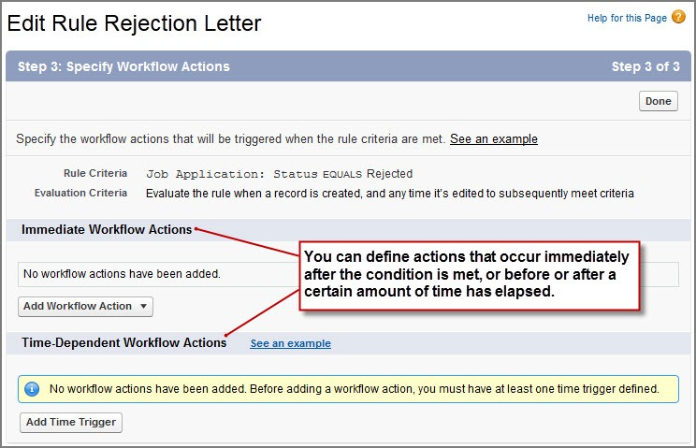

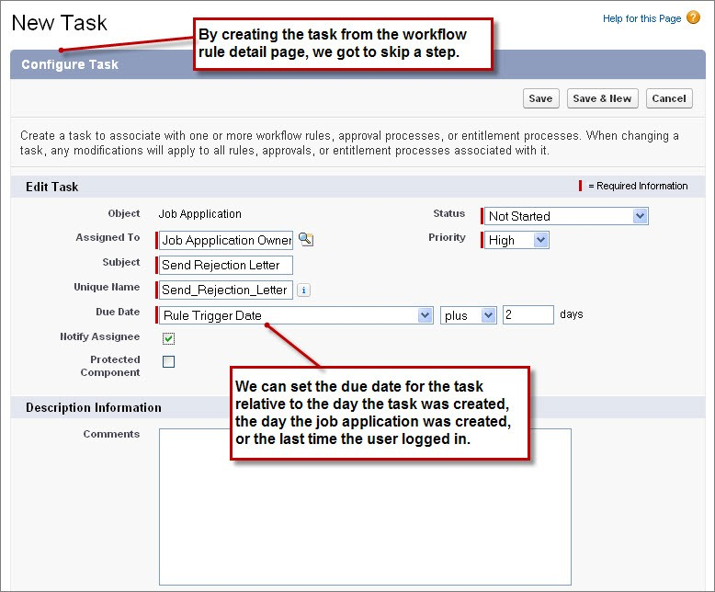

**Creating the “Extend an Offer” Workflow Rule and**

**Task**

To wrap up our first use case, we need to create another workflow rule for when the status of a job application is set to Extend an Offer. This rule and task are almost identical to the “Send Rejection Letter” workflow rule and task, so we'll just list the values that you'll need in the following two tables.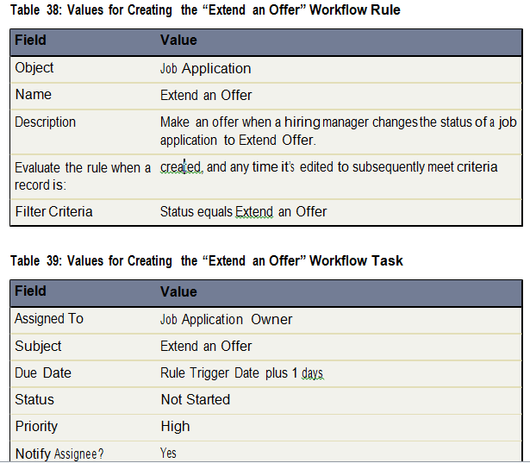

**Look at What We've Done**

Let's try out our new “Send Rejection Letter” workflow rule and see what happens:

**1.** Click the Job Applications tab, and select a job application record.

**2.** Click **Edit**, and change Status to Rejected.

**3.** Click **Save**.

The Send Rejection Letter task automatically appears in the Open Activities related list on the Job Application detail page, as shown in the following screenshot. 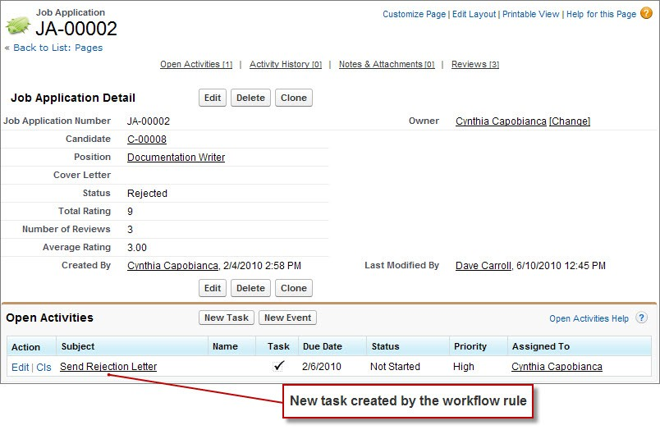

**Introducing Time-Dependent Workflow Actions**

As we mentioned earlier, time-dependent workflow actions are actions that occur before or after a certain amount of time has elapsed (for example, seven days before the value of the Hire By field, or three days after the workflow rule is triggered). We can use time-dependent workflow actions to fire tasks, field updates, and email alerts while the condition of a workflow rule remains true.

For example, the goal of reassigning position records to the Unclaimed Positions queue is to have the appropriate recruiter take ownership. However, there might be situations in which a position is placed in the queue and no recruiter claims it. Rather than leaving the position to languish unclaimed in the queue, we can define a time-dependent workflow action that alerts the recruiting manager if no recruiter claims a position record within a certain number of days. Because this action only takes place while the workflow condition remains true (that is, while the position is owned by a non-recruiter), the manager will only be alerted when necessary.

Neat, huh? Let's see how time-dependent actions are defined.

**Try It Out: Creating the “Notify Recruiting Manager”**

**Time-Dependent Workflow Task**

At this point, we should still be on the Edit Workflow Rule page for our Assign Position to Recruiter Queue workflow rule. If not, you can return there from Setup by clicking **Create** > **Workflow & Approvals** > **Workflow Rules**, clicking Assign Position to Recruiter, and then clicking **Edit** in the Workflow Actions area.

Before we can define a time-dependent workflow task, we first must specify a *time trigger*. Time triggers define when the time-dependent workflow actions should fire.

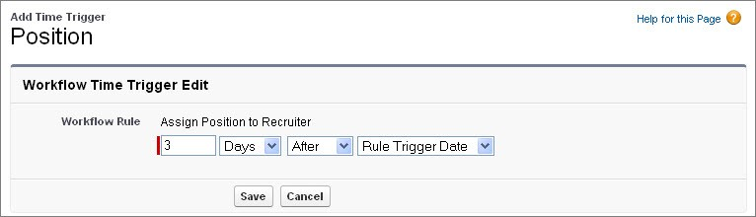

**Creating a Workflow Rule That Sends Email Alerts**

For our final workflow use case, let's create a workflow rule and email alert that sends a notification whenever a new position is created. We want all the employees at Universal

Containers to know when there are new positions available so they have the best opportunity to bring in referrals.

For this workflow rule, there's a step that we'll need to handle first: we need to design a template for what the email alert should look like.

**Introducing Email Templates**

Just as the platform includes built-in tools for setting security permissions, tracking events and tasks, and building business logic with workflow, it also provides a built-in tool for writing emails to users and contacts in your organization. *Email templates* allow you to create form emails that communicate a standard message, such as a welcome letter to new employees or an acknowledgement that a customer service request has been received.

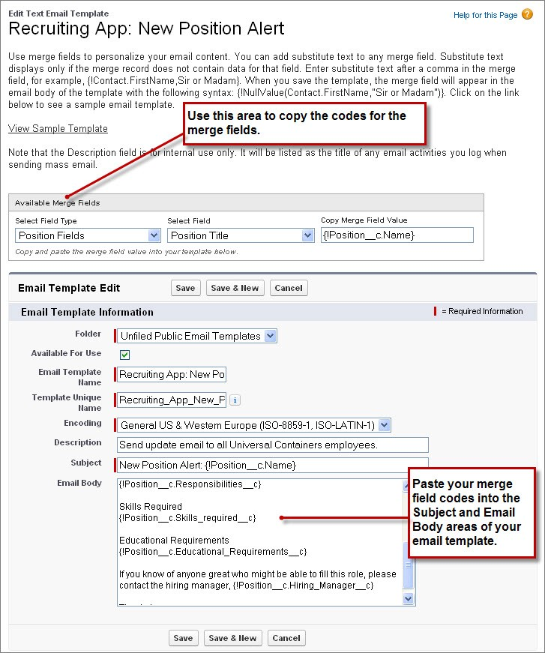

**Introducing Approvals**

Now that we've just made a handful of workflow rules, let's take a look at another business logic tool that the platform provides: *approval processes*.

Approval processes allow you to specify a sequence of steps that are required to approve a new record. Each step allows one or more designated approvers to accept or reject a record. The steps can apply to all records included in the process, or just to records that meet certain requirements. Like workflow, approval processes also allow you to specify actions—like sending an email alert, updating a field value, or assigning a task—that should occur whenever a record is approved, rejected, first submitted for approval, or recalled.

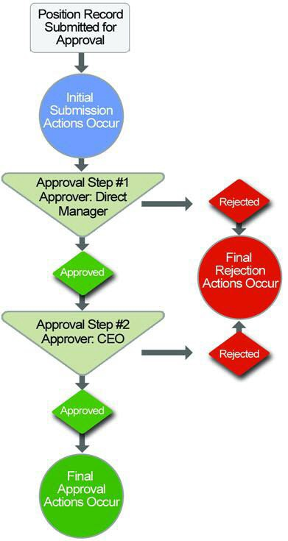

**Figure 80: Approval Processes Consist of Steps and Actions**

For example, your organization may have a three-tier process for approving expenses: submitted expenses that are less than $50 are automatically approved, those over $50 must be approved by a manager, and those over $5,000 must also be approved by a Vice President. In this example, your approval process would specify the following:

• If an expense record is submitted for approval, lock the record so that users cannot edit it and change the status to “Submitted.”

• If the amount is $50 or less, automatically approve the request.

• If the amount is greater than $50, send an approval request to the direct manager.

• If the amount is greater than $5,000 and the first approval request is approved, send an approval request to the Vice President.

• If all approval requests are approved, change the status to “Approved” and unlock the record.

• If any approval requests are rejected, change the status to “Rejected” and unlock the record.

For our recruiting app, we're going to define a similar approval process to submit new positions for approval. We want to make sure that a manager approves any position that his or her

employee creates, and that any position with a minimum salary of more than $150,000 is approved by the CEO. Let's get started.